CITY OF YORBA LINDA









4852 LAKEVIEW AVENUE CALIFORNIA 92886

# YORBA LINDA PUBLIC LIBRARY

++

**2022-2023 TEEN ADVISORY BOARD APPLICATION**

May 2, 2022

Dear Teen:

The Yorba Linda Public Library invites Yorba Linda teens, ages 13-18, to apply for the Teen Advisory Board (TAB) volunteering opportunity.

**Purpose:** To help the Yorba Linda Public Library meet the needs and interests of the teen population in the community.

Under close supervision, volunteers in the Teen Advisory Board will offer suggestions and provide input about teen reading interests, recreational activities, and programs. This will make the library more “teen-friendly.”

There are many benefits to being a part of the Teen Advisory Board, including: meeting and interacting with other teens, developing leadership and teamwork skills, feeling a sense of accomplishment by serving the community, and obtaining experience to use on high school and college applications. In addition, volunteer hours may be applied towards the high school community service requirement. This is a volunteer position; Teen Advisory Board members will not receive a stipend or any monetary compensation.

Board members are expected to attend monthly meetings as well as half the monthly teen events (generally 2 of 4 monthly teen events); these events include the Exposed Art & Literature Contest, Teen Film Festival, and Teen Summer Reading Program. These events are usually held Tuesday evenings and various Friday and Saturdays throughout the year. This one-year commitment begins September 2022 and runs through August 2023.

**Completed applications are due Saturday, June 11, 2022, before 4:59 P.M. at the Adult Information Desk. Postmarks will not be accepted. No exceptions.** Selected applicants will be called for an interview. Interviews will be conducted on Monday, June 27 and Tuesday, June 28. For more information, please call the Yorba Linda Public Library at (714) 777-2873, ext. 4617.

Sincerely,

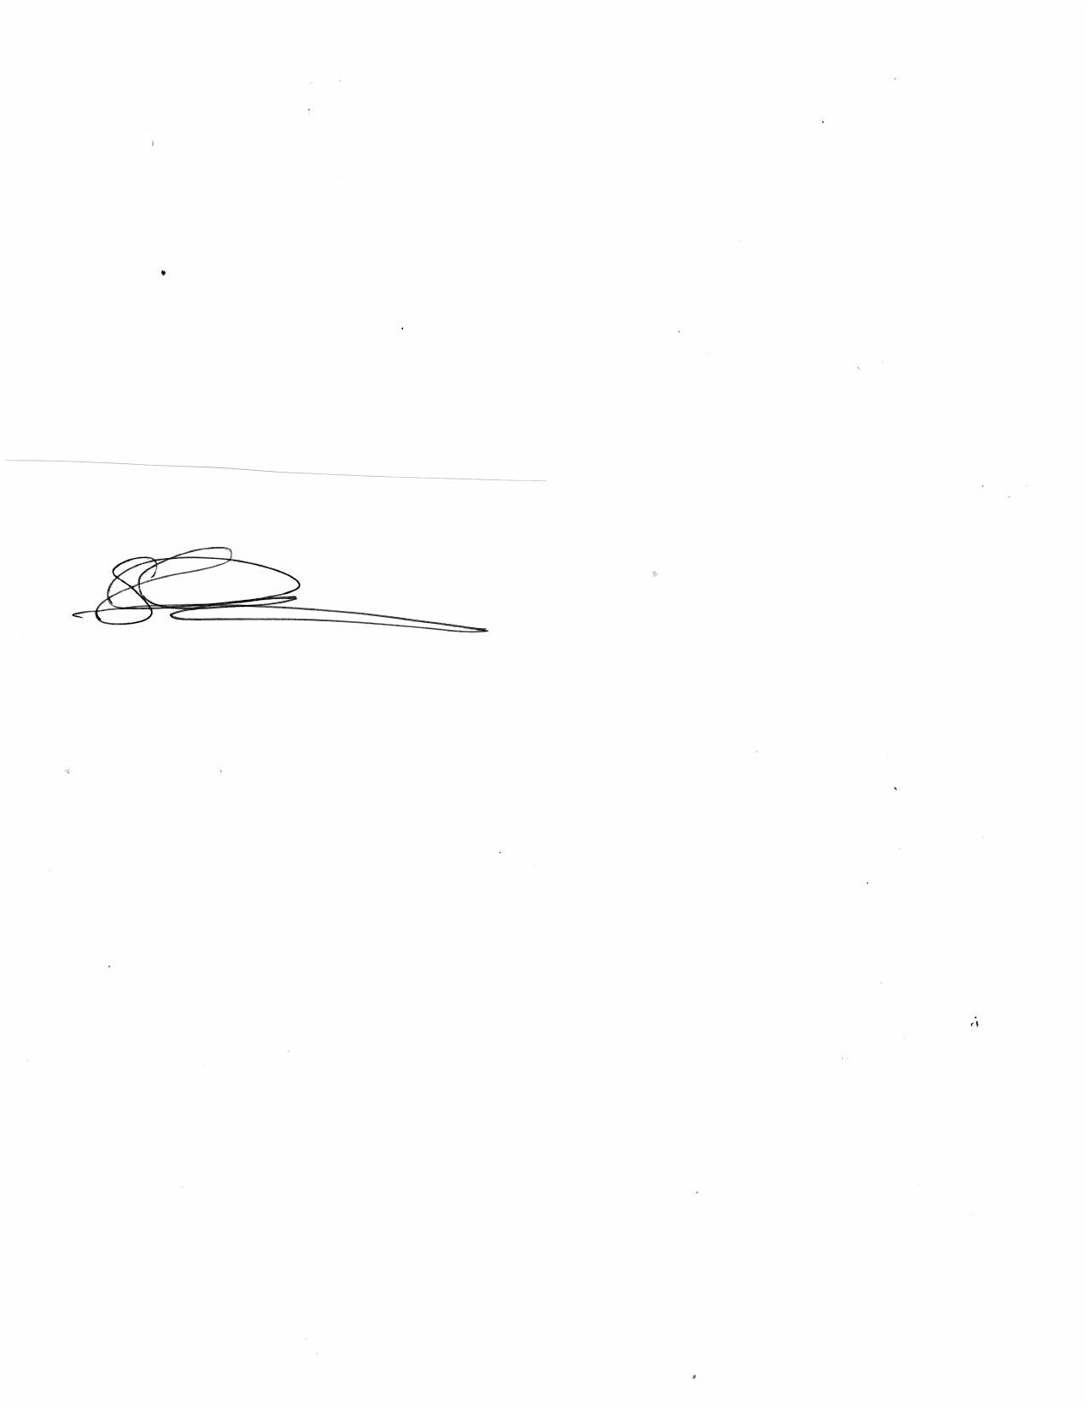

Elsa Huchim

Senior Librarian Assistant

GENERAL INFORMATION (714) 777-2873 ∙ WWW.YLPL.ORG

# BIRTHPLACE OF RICHARD NIXON – 37TH PRESIDENT OF THE UNITED STATES

# Yorba linda public library

# teen advisory board information

### Position

Teen Advisory Board (TAB) Member

### Description

The advisory team will help the Yorba Linda Public Library meet the needs and interests of the teen population in the community. The TAB offers suggestions and provides input about teen reading interests, recreational activities, and programming. Teen events at the Yorba Linda Public Library are offered on a monthly basis. Special events for teens are also offered on an annual basis. One of the main functions of the TAB is to help create, execute, and promote these events at their school. TAB members devote numerous personal hours to make teen events possible at the Yorba Linda Public Library.

### Duties

1. Participate and assist in planning and implementing weekly and annual library teen events and services (e.g., Book Discussions, DIY nights, Exposed Art Contest, Teen Film Festival, Teen Summer Reading Program, etc.).
2. Offer advice and assist in marketing teen events and services to teens in the community.
3. Suggest teen materials for purchase including books, audiobooks, e-books, music and games.
4. Other duties as assigned.

### Qualifications

1. Current Yorba Linda resident.
2. Ages 13-18.
   1. Accepted TAB members 18 years or older must be finger printed.
3. Have previous leadership experience.
4. Have current email address that is checked **at least** twice a week.
5. Basic knowledge of locating information on the Web.
6. Enthusiastic about providing ideas for teen programming/services.
7. Willingness to participate on a creative team.

***\*The deadline to turn in TAB Application is Saturday, June 11, 2022 before 4:59 p.m. Postmarks will not be accepted. No exceptions.***

### Commitment

1. One year – September 2022 to August 2023
2. Attend, participate, and assist in the supervision of teen events, including but not limited to Tuesday or Friday evenings from 5 PM to 8:00 PM, at least **2-6 times a month.**
3. Participate in monthly meetings.
4. Contribute **7 hours per month** to plan teen services, make recommendations, and assist with general library programs.
5. Respond promptly to TAB email/phone communication.
6. Assist with the Teen Summer Reading Program and other major events.

_____ **Initial.** I have read and understand the above duties, qualifications, and commitment required of a TAB member to the best of my knowledge.

# vOLUNTEER Application

# Yorba Linda Public Library Teen Advisory Board

## Please print or type

Name __________________________________________ Phone _______________

Street Address ________________________________________ Apt. ____________

City ___________________________ Zip Code ______________

School ____________________________________ Grade (in Fall) ______ Age ______

Email address **______________________________**

Please list any extracurricular activities in which you participate. Will any of these activities conflict with your commitment to volunteering on the Teen Advisory Board?

Describe a leadership role that you have held. What made the role challenging? What did you like and dislike about serving in a leadership role?

What are your current and past volunteer experiences? What have you enjoyed most about your previous volunteer experience?

What kinds of books do you like to read? Are there books we don’t have that you feel we should add to our collection?

Have you attended any teen events at the library? (Please circle) YES NO

If yes, what events have you attended?

Can you suggest any changes or additions to improve the library’s services to teens?

How did you hear about this opportunity?

Why would you like to be a part of the Teen Advisory Board?

**Certificate of Applicant:**

All answers and statements in this application are true and complete to the best of my knowledge. I understand any untruthful or misleading answers are cause for rejection of my application or of my disqualification from the Teen Advisory Board.

Signature _______________________________________ Date _________________

As the Legal Guardian of the participant on the Yorba Linda Public Library’s Teen Advisory Board, I also adhere to this policy. I hereby agree to indemnify and hold harmless the City of Yorba Linda and its officers, agents, or any third parties injured by the participant or any injury in any way arising out of the participant’s activities in this program.

Signature of Parent/Legal Guardian __________________________Date ____________

**TEEN ADVISORY BOARD**

**MEDICAL FORM**

Participant Name ______________________________ Home Phone ___________________

Address _______________________________________ City __________________________

Zip _________ Grade(in Fall) _________ Age _______ School _______________________

Please note any medical conditions or allergies we should be aware of for your child’s safety: ________________________________________________________________________

____________________________________________________________________________________________________________________________________________________________

### Emergency Contact Information

Parent’s Name ___________________________________ Work Phone ___________________

Other Contact’s Name __________________________________ Phone __________________

Parent’s Signature __________________________________ Date ___________________

**PHOTO/VIDEO RELEASE FORM**

**Yorba Linda Public Library**

PHOTO/VIDEO RELEASE- THE CITY OF YORBA LINDA may take, use and publish photos, videos, and/or audio recordings of participants for publicity purposes. I hereby grant the City permission to use my, or my child’s, likeness, name, voice and words in any broadcast, telecast, print or digital/social media account free of charge. IF THE PARTICIPANT IS A MINOR I hereby warrant that I am the custodial parent/legal guardian of the undersigned child, who is a minor. I CERTIFY THAT I HAVE READ, UNDERSTAND AND VOLUNTARILY SIGN THIS WAIVER AND RELEASE ON BEHALF OF MY HEIRS, SUCCESSORS, AND ASSIGNS AS IT APPLIES TO MYSELF AND TO ANY MINORS FOR WHOM I AM SIGNING.

I, CERTIFY THAT I HAVE READ AND UNDERSTAND THIS WAIVER AND RELEASE AND SIGN IT VOLUNTARILY.

**Name** *(please print)* **/ Child’s Name** (*if signing for minor)* **/ Signature** *(Adult participant or parent/legal guardian signature)*









CITY OF YORBA LINDA

4852 LAKEVIEW AVENUE CALIFORNIA 92886

# YORBA LINDA PUBLIC LIBRARY

# AUTHORIZATION TO CONSENT TO TREATMENT OF MINOR

I (We), the undersigned, parents of ________,

do hereby authorize the Yorba Linda Public Libraryof the City of Yorba Linda as agent(s) for the undersigned to consent to any x-ray examination, anesthetic, medical or surgical diagnosis or treatment and hospital care which is deemed advisable by, and is to be rendered under the general or special supervision of any physician and surgeon licensed under the provisions of the Medicine Practice Act.

It is understood that this authorization is given in advance of any specific diagnosis, treatment or hospital care being required, but is given to provide authority and power on the part of our aforesaid agent(s) to give specific consent to any and all such diagnosis, treatment or hospital care which the aforementioned physician in the exercise of his judgment may deem advisable.

By signing this authorization I/we agree to indemnify and hold harmless the City of Yorba Linda and all of its officers, employees, agents and volunteers from any and all liabilities for injury to persons and/or damage to property arising out of any act or omission in connection with this authorization for consent.

This authorization is given pursuant to the provisions of Section 6910 of the California Family Code.

This authorization shall remain effective for one year until August 2023, unless sooner revoked in writing to the City of Yorba Linda.

Dated Father

Mother

Legal Guardian

GENERAL INFORMATION (714) 777-2873 ∙ WWW.YLPL.ORG

BIRTHPLACE OF RICHARD NIXON – 37TH PRESIDENT OF THE UNITED STATES